“Intelligent Bicycle Dash Cam”
Project Definition and Requirements
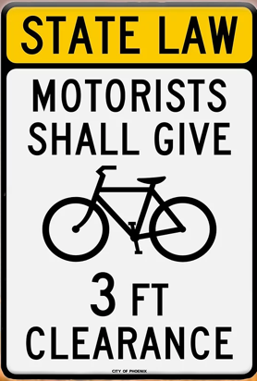

Sponsors
Arizona State University (contact: Robert Heinrichs Robert.heinrichs@asu.edu)

Background
Every year, over 13,000 cyclists get injured in the United States due to car accidents.
In Arizona, A.R.S 28-275 requires vehicles to maintain a 3 feet distance from cyclists, but there is no enforcement mechanism for this law. Intelligent Bicycle Dash Cam (IBDC) aims to provide a safer environment for cyclists by creating a mechanism for the enforcement of A.R.S. 28-275

IBDC is an automobile proximity sensing, warning, and reporting device that fits in the left handlebar of a bicycle. When a motor vehicle passes within 3-feet of the IBDC a distance sensor triggers a side-facing flashing amber LED to warn the driver and records a burst of images (~12 images per second) from a forward-facing camera to capture the license plate. These images are stored on a micro-SD within the device for export to a smartphone. These images can be sent to law-enforcement to track unsafe driving incidents and send warnings to unsafe drivers when permitted by law. Image analysis can be used to retrieve the license plate number from the images.

Project Goals / Requirements
The goal of the current project is to develop the next generation of smartphone app for Android and iOS which incorporates:
- An interface that allows the exchange of data between device and smartphone. This includes sending settings data to the device, retrieving incident data from the device (measured distance and images), retrieving status information from the device (e.g., battery status, SD card usage). Note: Interface (likely Protobuf) will be provided.
- Capturing the time and GPS coordinates of incident when reported to the smartphone by device.
- Allow user to add additional information to incidents (general comments (text), rider injured (minor/serios/none), driver (left/stayed), driver name (text), other driver information (text), license plate number (7 character text), vehicle make/model/color (text each, possible drop down with typical values)).
- Store incidents with all data locally on the smartphone.
- User can view all stored incidents and edit incidents (e.g., add comments, change additional information, select best image, enter license plate number as text).
- User can delete specific incidents with all associated data (e.g., images) in case of a false-positive.
- User can view series of images of an incident and select best image.
- Device page that allows the user to connect to a device (pairing), see information of a connected device (e.g., battery level, SD card usage), and change device settings (e.g., how many pictures should be taken per incident). Device page should allow the addition of other information and/or settings in the future.
- Settings page that allows the user to change smartphone app settings (e.g., upload incident data anonymously to server). Settings page should allow the addition of other settings in the future.

Nice to have / lower priority requirements:
- App automatically finds license plate in image and shows it zoomed in on the incident view.
- App uses OCR to automatically extract the license plate number as text. User can be asked to confirm if detection was correct.
- Export incident as pdf file, which contains all information about the incident.

